**ERD Model PART 3**

Projects require planning before action. An essential skill is to learn how to use different tools to communicate your plans. To practice this valuable skill, you will do the following:

1. Create an ERD using UML This must be a **physical model.**

2. Create a second ERD using Crow’s Foot notation. This will be a **logical model**.

Make a copy of each drawing in your **Report**. Do not submit the data file of the drawing itself.   
(screen captures work best)

3. Finally, write a description of the relationships. Using the time/sales/store/product example from Week 2, you might write:   
   
Sales depends on 1 and only 1 time entity, 1 or zero store (online sale) , and 1 or many products.

Write a similar description for every line in your drawing. 4 lines = 4 relationship statements.  
  
Be sure you address all arrows in your drawing like the example does with descriptions like ‘1 or..’ , ‘1 and...’, ‘0 or more’

**Scoring:**

10 points for the UML drawing in your report

10 points for the Crow’s Foot drawing in your report

10 points for a full set of relationship descriptions.

**Total score: 30 points**

**REMINDER: Use a screen capture to save an image of your drawing into your report. Do NOT submit the data file containing the drawing!!**

The following sections contain useful information to help you complete the assignment.

**UML**

You can choose EITHER 1) download Umlet, OR 2) Use draw.io to lay out your diagram. I’ll describe both, and you may choose which tool you prefer. Both are easy and involve simple layout tools. All software here are free to use.

**1. Umlet**

Go to [www.umlet.com](http://www.umlet.com) and download the appropriate version for your system.

Simply choose the shape in the tool area on the right side of the program and drag a copy of it to the layout area. Drag arrows by the square in the middle. To change the text in one of the shapes, select the shape then edit the text in the text editing window. It’s a little odd because you aren’t writing inside the shape, but trust that your text will appear in the right place when you finish. Remember to use a screen capture to save your drawing!

See the following examples:

These are the tools that appear by default on a new screen:

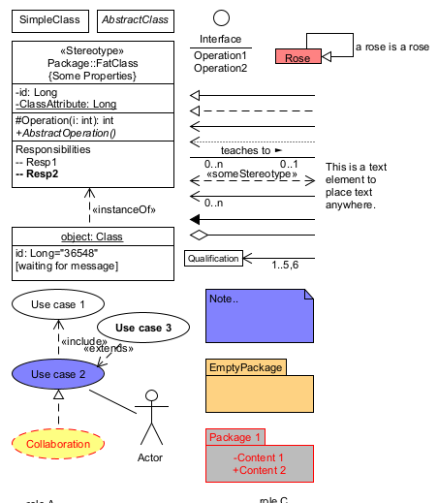

Just double-click or drag a shape to the main window to make a copy. Don’t modify the tools on the right or you’ll change the template. Arrows can also be dragged or double-clicked. Use the square in the middle to control the arrow.

|  |  |
| --- | --- |
|  |  |

To add text to the inside of a shape, select the shape then begin typing in the **Properties** window below the tools.  
  
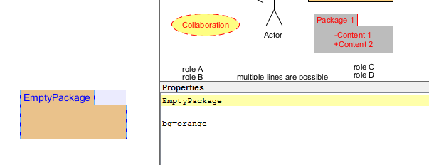

I selected the shape on the left, then began editing the text in the Properties window on the right.

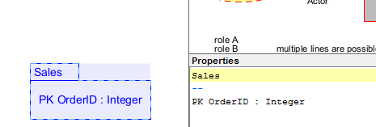  
  
That’s all there is to it! However, maybe you prefer using an online tool instead. Let’s look at Draw.io

**2. Draw.io**

draw.io forwards to app.diagrams.net Here you can create various styles of UML drawing. Start a new drawing, choose to save to your device if the site asks, then choose ‘new > UML (8)’, and pick your favorite style.

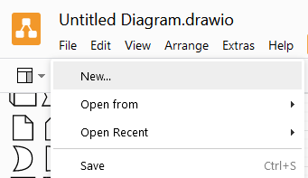

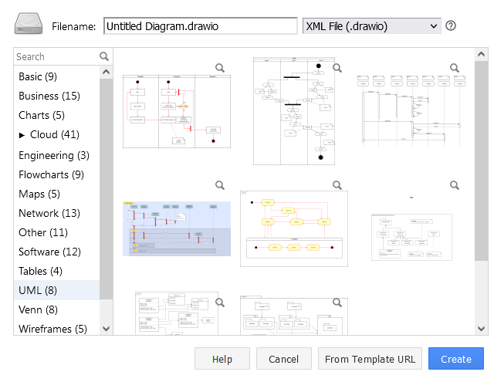

The one on the bottom-left looks simple enough:

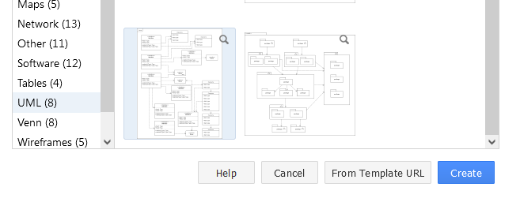

Once you open a template, you will probably want to clear the screen first. However, take a minute to get used to the tools and understand what tool creates which element. Then clear the screen.

The appropriate UML tools are under the UML section on the left.

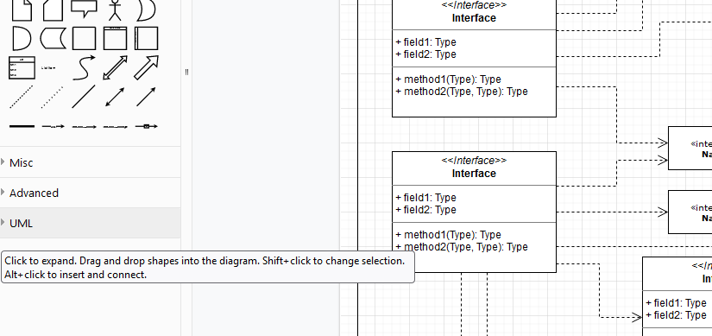

If you click on the various block tools, you’ll find a shape that fits various model types:  
  
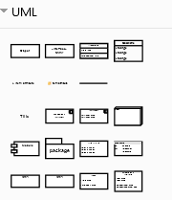 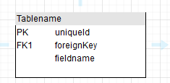

Finally, double-click on a string of text to edit it. In this case you are editing text directly in the shape. You can remove a field just by deleting it. The left side is a new shape, and the right side shows two shapes with edits.

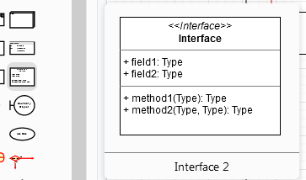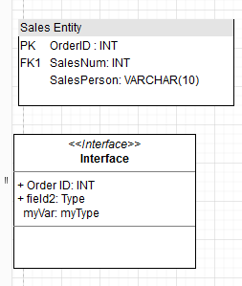

Editing the text is a little more challenging, and the arrows are a bit odd to position, but you’ll get the hang of it quickly.

If you don’t want to show the grid lines in the background, go to the View menu, and uncheck ‘Grid’. I’ll accept either setting in your report.

**Crow’s Foot**  
  
Various tools can help you draw a diagram. However, all you really need are a few rectangles, arrows, and the appropriate markers that indicate the relationships such as 1 to 1, 1 to many, etc.

Again, Draw.io has a few tools that are easy. Use the template under New > Basic > Entity Relation Diagram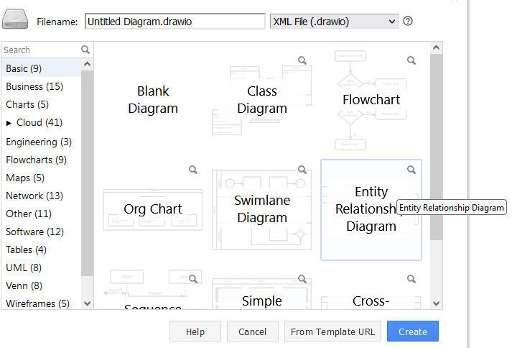

You will find the Crow’s Foot tools under the Entity Relation section on the left side.  
  
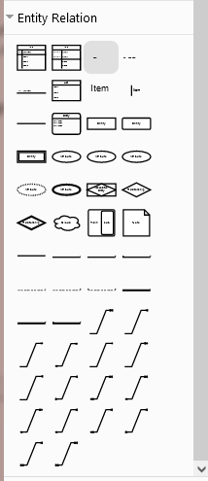 Select one of the arrows:

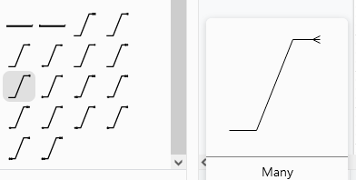

When you add

a new arrow, it appears in the middle of the screen:

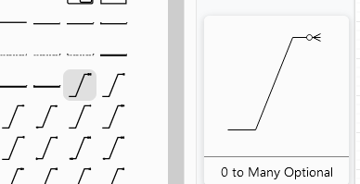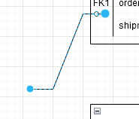

You can drag the arrow by ‘grabbing’ the middle, or drag each endpoint to where you want it to go.

|  |  |
| --- | --- |
|  | Whether you drag the whole line or just an end, if you place the point on the edge of a shape, it will connect.  I dragged the LEFT endpoint to the block on the left. I could have also dragged the whole line so that when the end point was on the block, the block would highlight and the line would connect. Either way, it’s your choice. |
|  |  |

Using these drawing tools can make the job very quick and efficient. When you finish, take a screen capture and copy the drawing into your report.